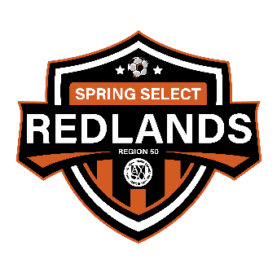REDLANDS SPRING SELECT
2023-2024

Dear Parents,

Congratulations!

I am delighted to inform you we would like to offer John Doe a place on the Boys u12 Spring Select All Stars team for the 2023/2024 season.

To accept this invitation, please inform me of your decision (acceptance or denial) within the next 24 hours via email reply. Additionally, parents must print, sign and turn in the “Spring Select Commitment” letter. (You can also e-sign and submit via PDF) The commitment letter outlines some important information, so please read carefully.

I will then be in touch with further details on next steps moving forward including team parent meeting, player registration, practices, and ordering uniforms.

Feel free to reach out if you have any questions,

Respectfully,

Coaches Name
(909) 999-9999
Coach Email

